ThunderStorm analysis protocol: 01) If not installed ThunderStorm is a Fiji/ImageJ plugin that can be installed (https://github.com/zitmen/thunderstorm) and https://zitmen.github.io/thunderstorm/.
02) Once the software has been installed first configure the camera settings as necessary. This can be achieved via
Plugin→ ThunderStorm → camera setup
Pixel size: 160
A/D count: 15.1
Quantum efficiency: 1.0
Base Level [A/D count]: 166
EM GAIN: 800
Once the camera setup has ben configured PRESS the OK and then open the image of choice to be able to run the software
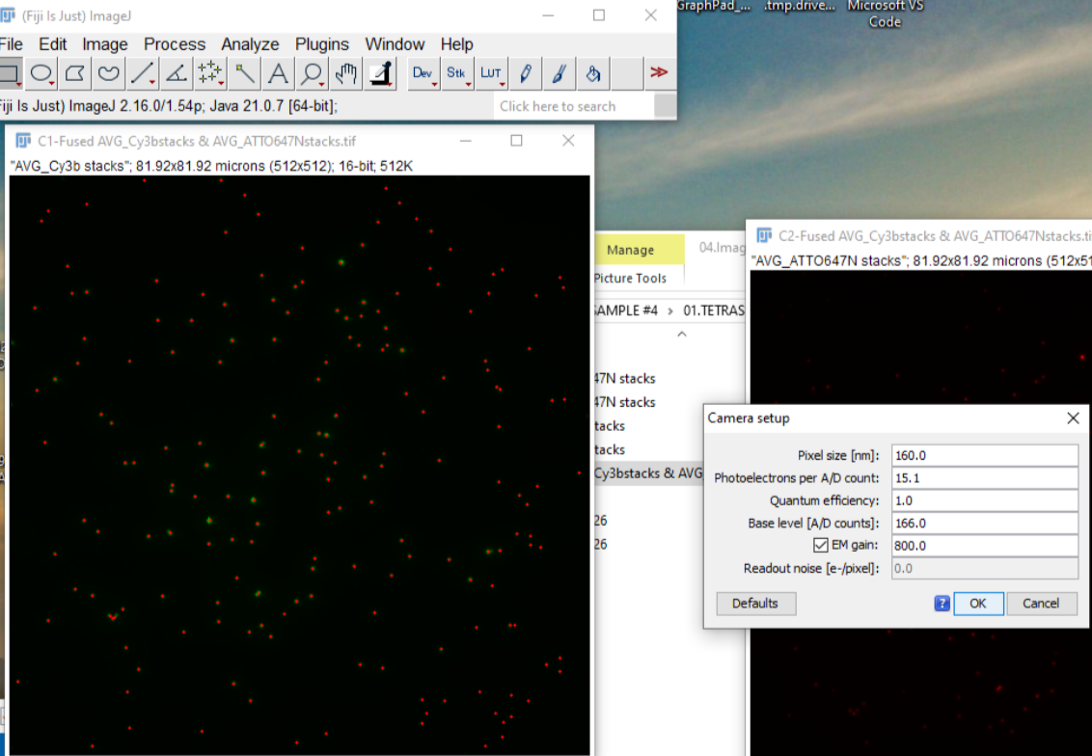03) Once the image (TIFF) has been opened run Plugin → ThunderStorm → Run Analysis
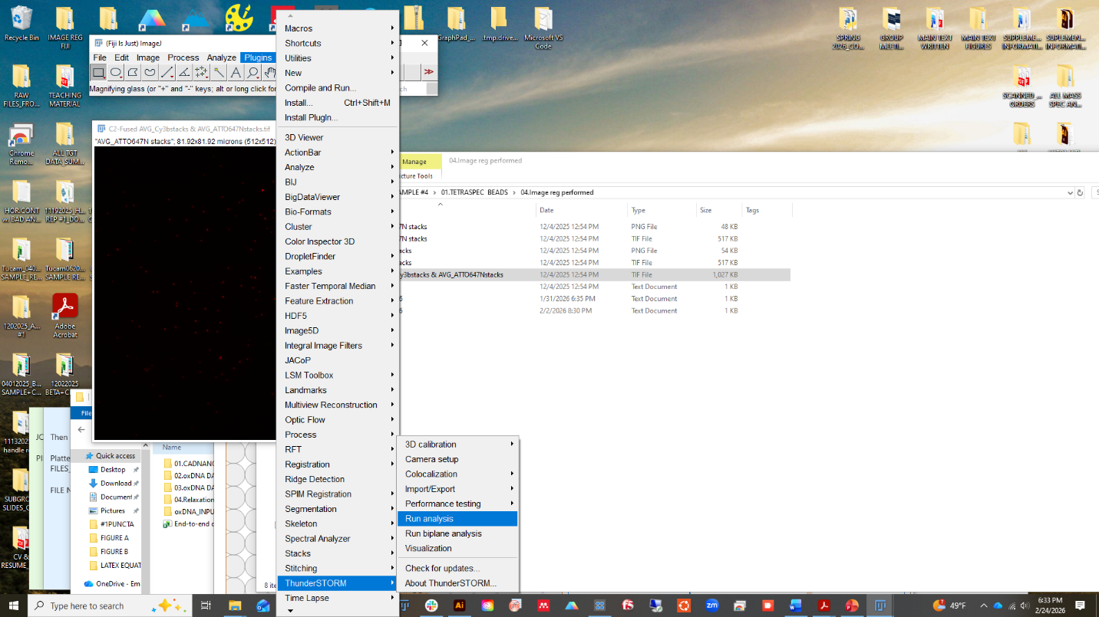04) A pop-up menu will appear. Hit ok on the popup menu. The analysis features are shown below. Use said features and run the sample
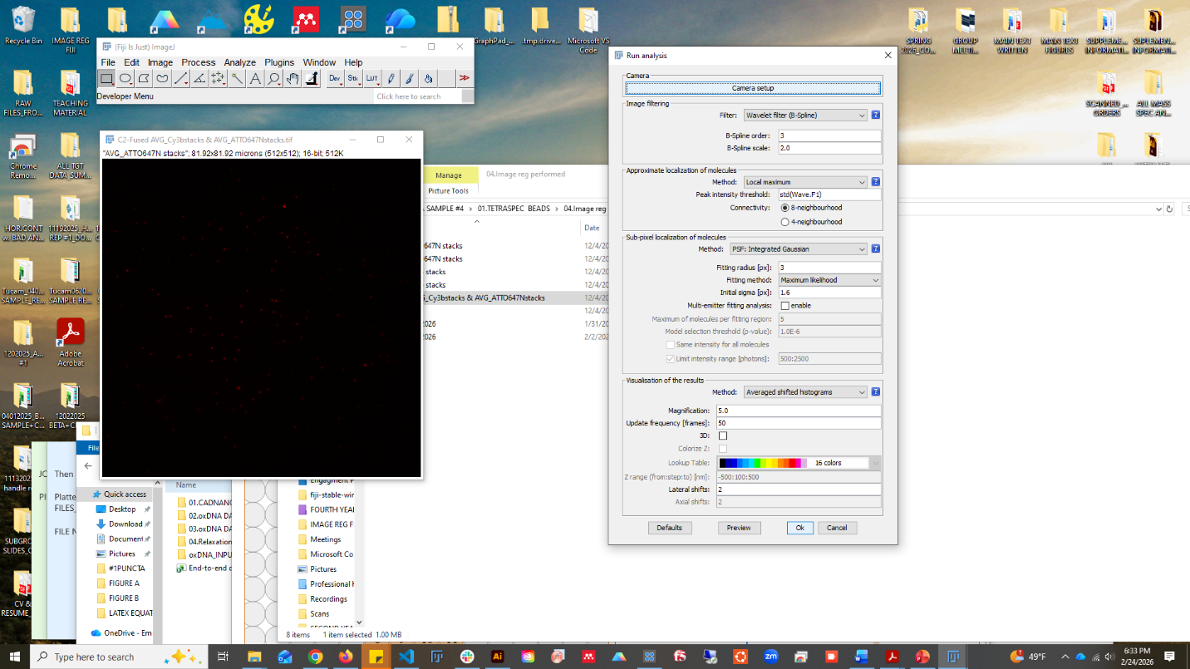05) The results will appear as a shown in the image below
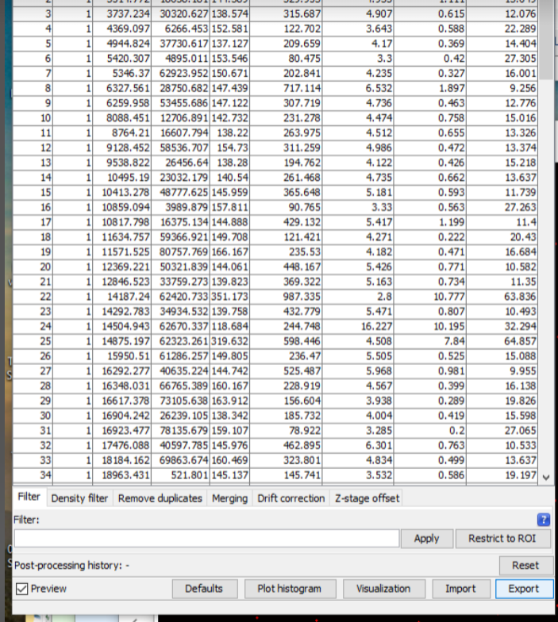06) For the next phase of the analysis the .CSV files are necessary and this "Export" is a function we must use for the purposes of exporting the csv file
07) Once the export button has been pressed, a new popup window will appear. For the file path choose a location of interest. For the columns to export, double check and make sure the ID value is checked and all the other boxes are checked. Once checked hit ok and a new csv file will be created.
